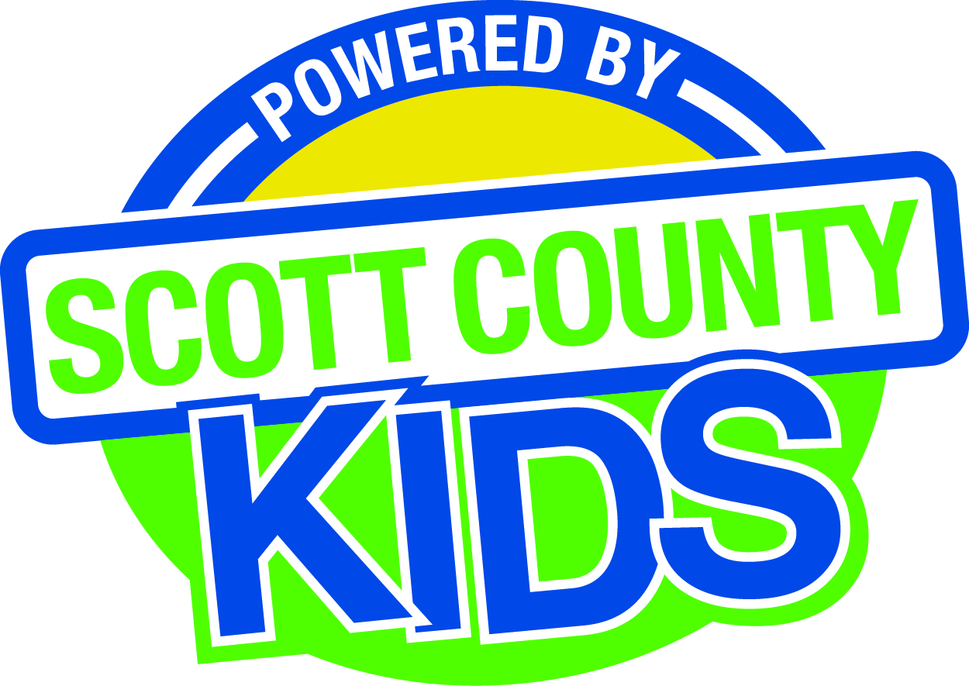
Scott County Kids Early Childhood Iowa Board
Meeting of December 1, 2015
Scott County Administrative Center
600 W. 4th Street, Davenport
Room 605
11:30am – 1:00 pm
You are welcome to bring your brownbag lunch.

Agenda
- Call to Order –Larry Barker, Chair
- Introductions

- Approval of Minutes for November 3, 2015

- Old Business
- Fiscal Issues
- FY16 Expenditures

- New Business
  - Early Childhood Coordinating Council
  - Committee Reports
- Contracts Management
- Committee Report
- Maternal Infant Early Child Home Visitation
- Family Connects
- Outcomes
- Committee Report
- Nominations
- Committee Report
- Election of Officers
- Public Awareness
- Committee Report
- Public Awareness Activities Evaluation Tool
- Community Meetings
  - State Early Childhood Iowa
    - State ECI Board Meeting: 11/6/15 Report from Clewell
    - State ECI Coordinator Meeting: scheduled for 12/9/15
  - Legislative Recap

- Other Business

- Public Input

- Next Meeting January 5, 2016

