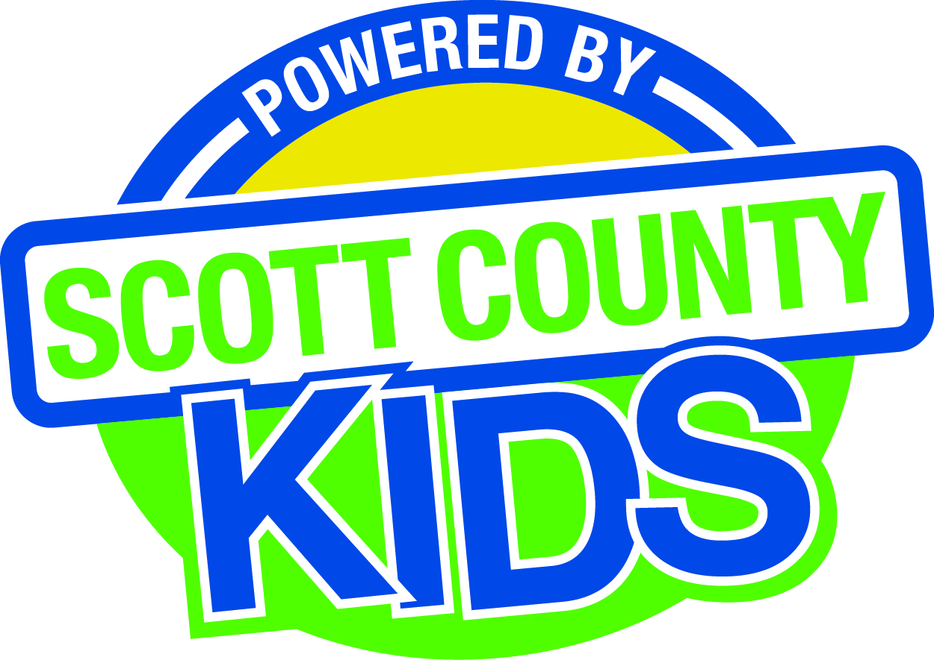
Scott County Kids Early Childhood Iowa Board
Meeting of January 6, 2015
Scott County Administrative Center
600 W. 4th Street, Davenport
1st Floor Board Room
11:30am – 1:00 pm
You are welcome to bring your brownbag lunch.

Agenda
- Call to Order –Larry Barker, Chair
- Introductions

- Approval of Minutes for November 4, 2014 and December 2, 2014
- Approval of revised Minutes for September 2, 2014

- Old Business
- Fiscal Issues
- FY15 Expenditures
- Maternal, Infant and Early Childhood (MIECHV)

- New Business
  - Presentation: Child Care & Preschool Scholarships
  - Audit
  - Early Head Start
  - Amendment to State Early Childhood Iowa Contract
  - Early Childhood Coordinating Council
  - Committee Reports
- Contracts Management
- Committee Report
- Outcomes
- Committee Report
- REDCap
- Nominations
- Election of Officers
- Committee Report
- Public Awareness
- Committee Report
- Community Meetings
- Levels of Excellence
  - State Early Childhood Iowa
    - State ECI Board Meeting: Next meeting 1/9/15
    - State ECI Coordinator Meeting: 12/9/14 Report from Martens
    - Early Childhood Iowa Alliance Meeting 12/11/13
  - Legislative Recap

- Other Business

- Public Input

- Next Meeting February 3, 2015

