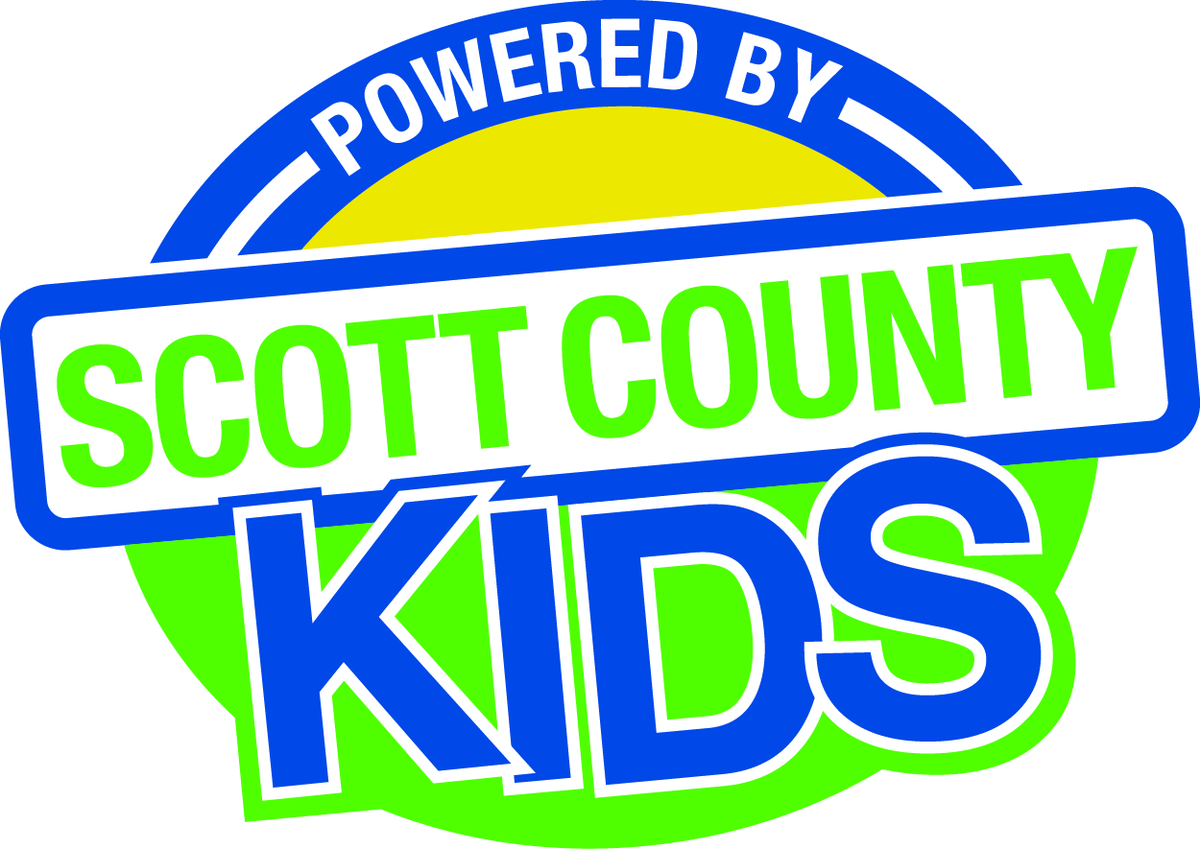
Scott County Kids Early Childhood Iowa Board
Meeting of August 4, 2015
Scott County Administrative Center
600 W. 4th Street, Davenport
First Floor Boardroom
11:30am – 1:00 pm
You are welcome to bring your brownbag lunch.

Agenda
- Call to Order –Larry Barker, Chair
- Introductions

- Approval of Minutes for June 2nd 2015

- Old Business
- Fiscal Issues
- FY15 Expenditures
- FY16 Expenditures
- FY16 Budget
- Levels of Excellence
  - Board survey
- Maternal, Infant and Early Childhood (MIECHV)

- New Business
  - Presentation: Tiffany Tpepkes, Scott County Health Department
  - Early Childhood Coordinating Council
  - Committee Reports
- Contracts Management
- Carry forward
- CPR 1st Aid Scholarships
- AIM4Excellence
- Bright Beginnings and NEST
- Family Connects
- Site Visit Summary
- Outcomes
- Nominations
- Public Awareness
  - Evaluation and Salary Adjustment for Coordinator

  - State Early Childhood Iowa
    - State ECI Board Meeting: 6/5/15 Report from Clewell
    - State ECI Coordinator Meeting: 6/26/15 Report from Martens
  - Legislative Recap

- Other Business

- Public Input

- Next Meeting September 1st 2015

