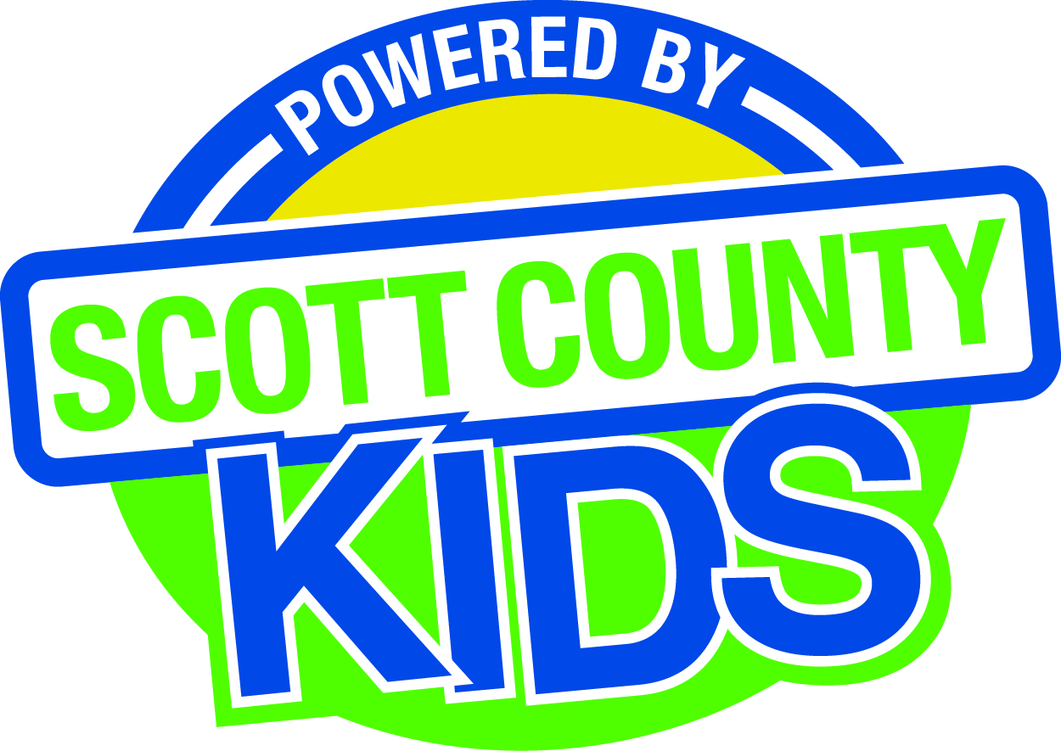
Scott County Kids Early Childhood Iowa Board
Meeting of October 6, 2015
Scott County Administrative Center
600 W. 4th Street, Davenport
Room 605
11:30am – 1:00 pm
You are welcome to bring your brownbag lunch.

Agenda

- Call to Order –Lawrence Barker, Chair
- Introductions

- Approval of Minutes for September 1, 2015

- Old Business
- Fiscal Issues
- FY16 Expenditures
- Bylaws (action item)
- Services Out of Area (action item)
- Policies and Procedures
- Community Plan
- Maternal, Infant and Early Childhood Home Visitation

- New Business
  - Presentation: Liam Healy, DHS
  - Review of Independent Audit Report FY14
  - Early Childhood Coordinating Council
  - Committee Reports
- Contracts Management
- Committee Report
- Outcomes
- Committee Report
- Nominations
- Committee Report
- Re-election
- Election of new member
- Resignation
- Public Awareness
- Committee Report
- Community Meetings
  - State Early Childhood Iowa
    - State ECI Board Meeting: 9/11/15
    - State ECI Coordinator Meeting: 9/16/15
    - State ECI Alliance Meeting:9/15/15
  - Legislative Updates

- Other Business

- Public Input

- Next Meeting November 3, 2015

