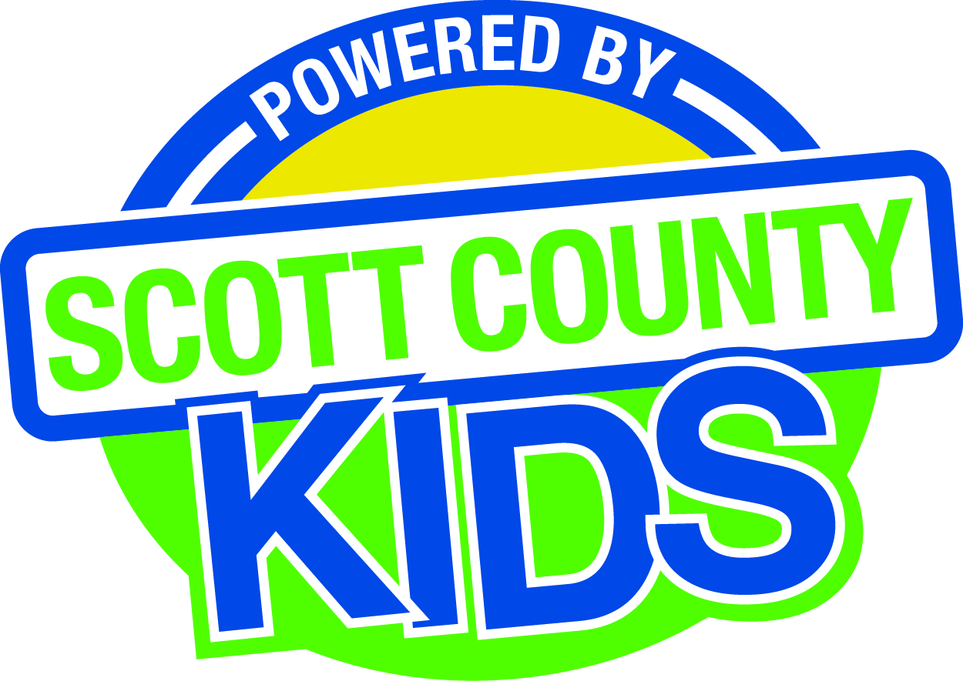
Scott County Kids Early Childhood Iowa Board
Meeting of November 3, 2015
Scott County Administrative Center
600 W. 4th Street, Davenport
Room 605
11:30am – 1:00 pm
You are welcome to bring your brownbag lunch.

Agenda
- Call to Order –Larry Barker, Chair
- Introductions

- Approval of Minutes October 6, 2015

- Old Business
- Fiscal Issues
- FY16 Expenditures
- Bylaws (Action Item)
- Community Plan (Action Item)

- New Business
  - Presenter: Mary Jo Huddleston, Child Care Resource and Referral
  - Early Childhood Coordinating Council
  - Committee Reports
- Contracts Management
- Committee Report
- Maternal Infant Early Childhood Home Visitation
- Outcomes
- Committee Report
- Nominations
- Committee Report
- Officers
- Public Awareness
- Committee Report
- Community Meetings
  - State Early Childhood Iowa
    - State ECI Board Meeting: scheduled for 11/6/15
    - Regional ECI Coordinator Meeting: 12/9/15
  - Legislative Recap

- Other Business
  - First Five
  - Letter to State ECI Board

- Public Input

- Next Meeting December 3, 2015

