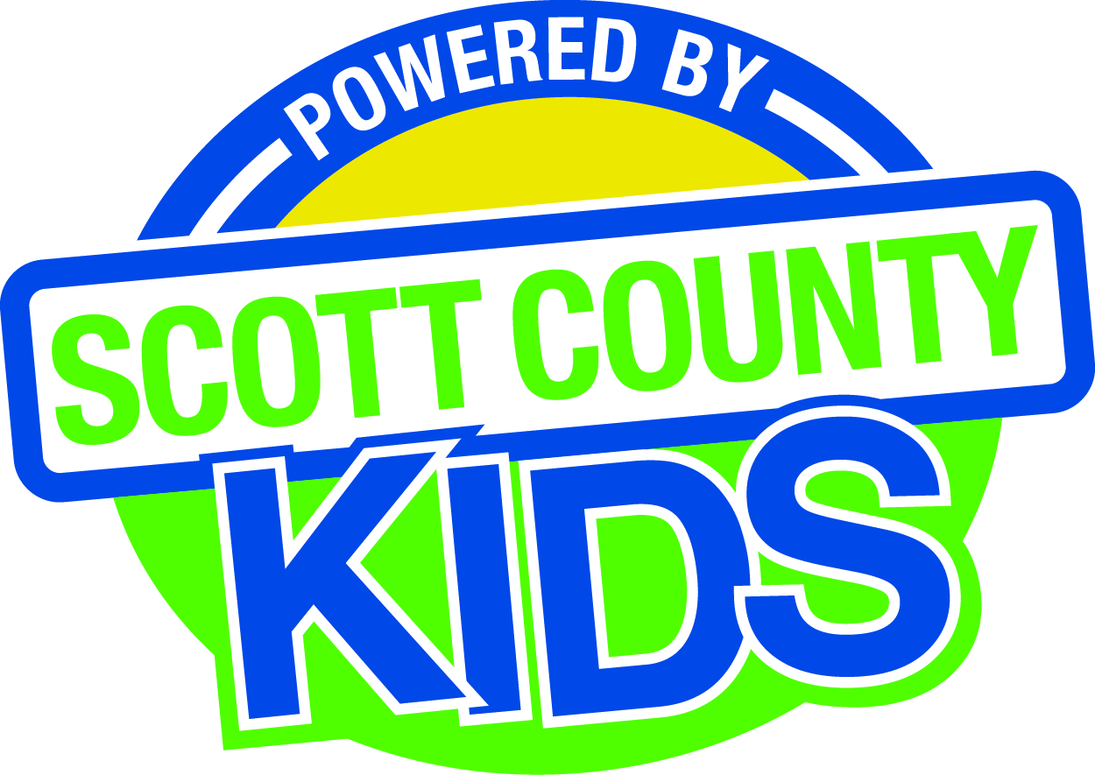
Scott County Kids Early Childhood Iowa Board
Meeting of November 4, 2014
Mississippi Bend AEA
729 21st Street, Bettendorf
Meeting Room 2
11:30am – 1:00 pm
You are welcome to bring your brownbag lunch.

Agenda

- Call to Order –Larry Barker, Chair
- Introductions

- Approval of Minutes October 7, 2014

- Old Business
- Fiscal Issues
- FY15 Expenditures

- New Business
  - Presenter: Angie Kendall, Child Abuse Council, Intro to TIC and ACEs
  - Early Childhood Coordinating Council
  - Committee Reports
- Contracts Management
- Committee Report
- Outcomes
- Committee Report
- Nominations
- Committee Report
- New Board Member Nomination
- Public Awareness
- Committee Report
- Community Meetings
  - State Early Childhood Iowa
    - State ECI Board Meeting: scheduled for 11/7/14
    - Regional ECI Coordinator Meeting: 10/31/14
    - State ECI Coordinator Meeting: scheduled for 12/3/14
  - Legislative Recap

- Other Business

- Public Input

- Next Meeting December 2, 2014

