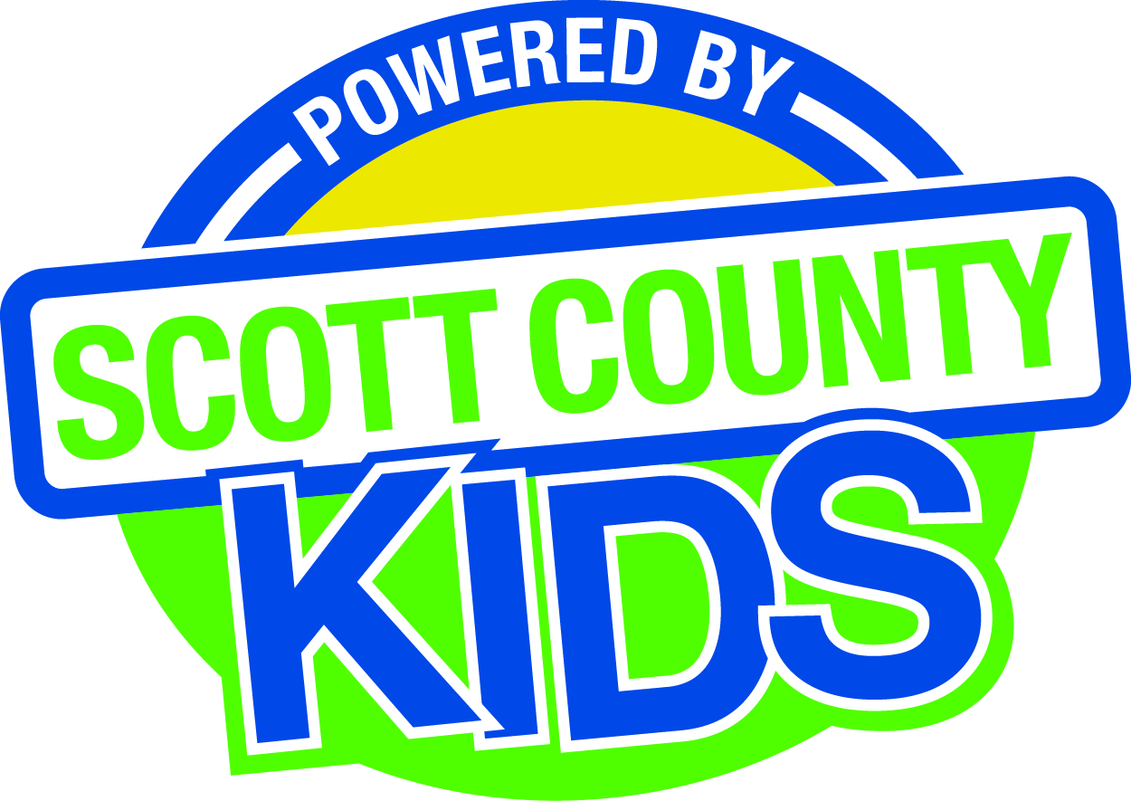
Scott County Kids Early Childhood Iowa Board
Meeting of April 7, 2015
Scott County Administrative Center
600 W. 4th Street, Davenport
Room 605
11:30am – 1:00 pm
You are welcome to bring your brownbag lunch.

Agenda
- Call to Order –Larry Barker, Chair
- Introductions

- Approval of Minutes for March 3, 2015

- Old Business
- Fiscal Issues
- FY15 Expenditures
- Levels of Excellence
  - Community Focus Group
  - Board Retreat
- Maternal, Infant and Early Childhood (MIECHV)
- Muscatine ECI

- New Business
  - Presentation: Quality Child Care, Child Care Resource and Referral
  - Early Childhood Coordinating Council
  - Committee Reports
- Commitments to committees
- Contracts Management
- Committee Report
- Outcomes
- Committee Report
- Nominations
- Committee Report
- New member nomination
- Public Awareness
- Committee Report
- Community Meetings
  - State Early Childhood Iowa
    - State ECI Board Meeting: 4/3/15 Report from Clewell
    - State ECI Coordinator Meeting: 4/8/15 Martens to report at May meeting
    - Day on the Hill report from Martens
  - Legislative Recap

- Other Business

- Public Input

- Next Meeting May 5, 2015

