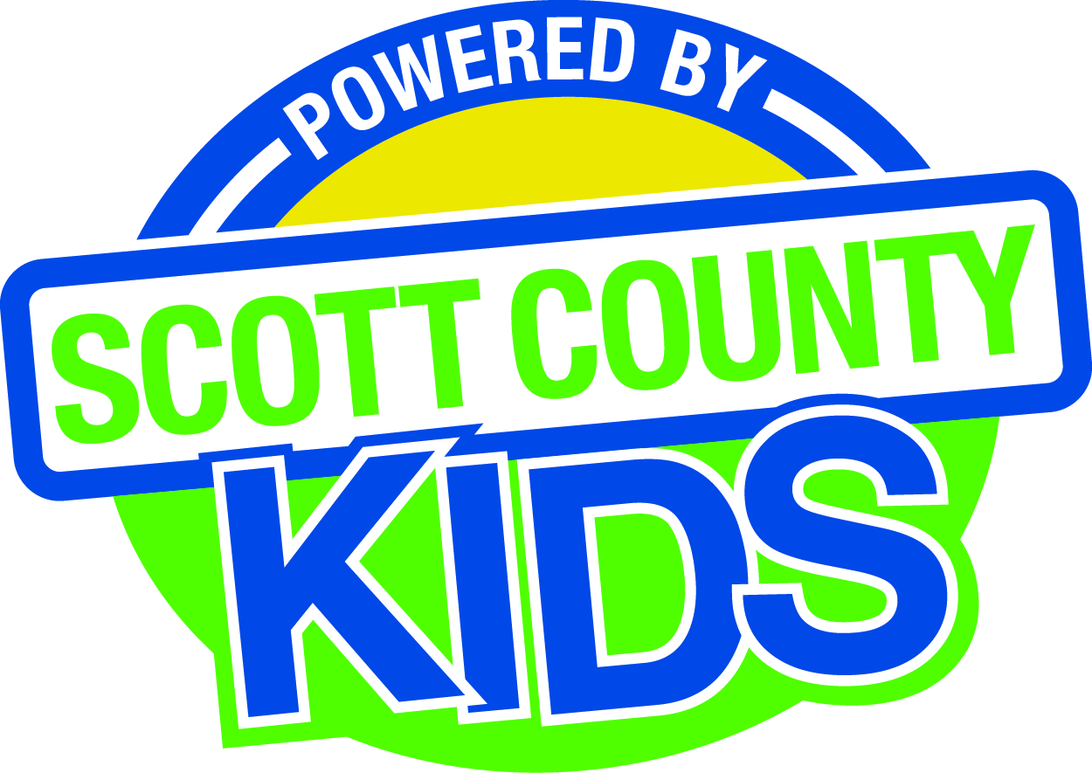
Scott County Kids Early Childhood Iowa Board
Meeting of January 7, 2016
Scott County Administrative Center
600 W. 4th Street, Davenport
1st Floor Board Room
11:30am – 1:00 pm
You are welcome to bring your brownbag lunch.

Agenda

- Call to Order –Marc Engels, Chair
- Introductions

- Approval of Minutes for December 1, 2015

- Old Business
- Fiscal Issues
- FY16 Expenditures
- Maternal, Infant and Early Childhood (MIECHV)

- New Business
  - Audit
  - Early Childhood Coordinating Council
  - Committee Reports
- Contracts Management
- Committee Report
- Family Connects
- Outcomes
- Committee Report
- Nominations
- Committee Report
- Public Awareness
- Committee Report
- Community Meetings
- Levels of Excellence
  - State Early Childhood Iowa
    - State ECI Board Meeting: Next meeting:
    - State ECI Coordinator Meeting: 12/10/15 Report from Martens
  - Legislative Recap

- Other Business

- Public Input

- Next Meeting February 2, 2016

