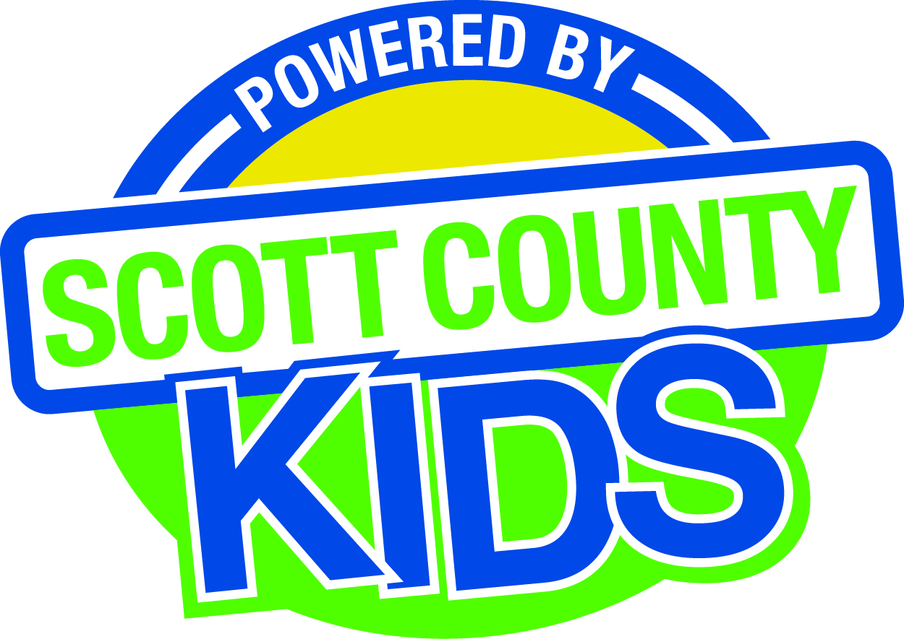
Scott County Kids Early Childhood Iowa Board
Meeting of June 2, 2015
Scott County Family Y
624 E. 4th Street, Davenport
Board Retreat: 9:00am
Board Meeting: 11:30am – 1:00 pm
Agenda
- Call to Order –Larry Barker, Chair
- Introductions

- Approval of Minutes for May 5, 2015

- Old Business
- Fiscal Issues
- FY15 Expenditures
- Levels of Excellence
- Maternal, Infant and Early Childhood (MIECHV)

- New Business
  - Review Community Wide Indicators and Trend Data
  - FY 16 Proposed Budget
  - FY16 Processes
    - Insurance
    - Fiscal Agent
    - Review Policies
  - Early Childhood Coordinating Council (Deb Gustafson)
  - Committee Reports
- Contracts Management
- Committee Report
- Quality Child Care
- Outcomes
- Committee Report
- Nominations
- Committee Report
- Public Awareness
- Committee Report
- Community Meetings
  - State Early Childhood Iowa
    - State ECI Board Meeting 6/5/15 Report from Clewell at August meeting
    - State ECI Coordinator Meeting: 9/16/15Report from Martens at October meeting
  - Legislative Recap

- Other Business
  - Schedule of FY16 Meetings
  - Conflict of Interest Statement and Board Survey

- Public Input

- Next Meeting August 4, 2015

