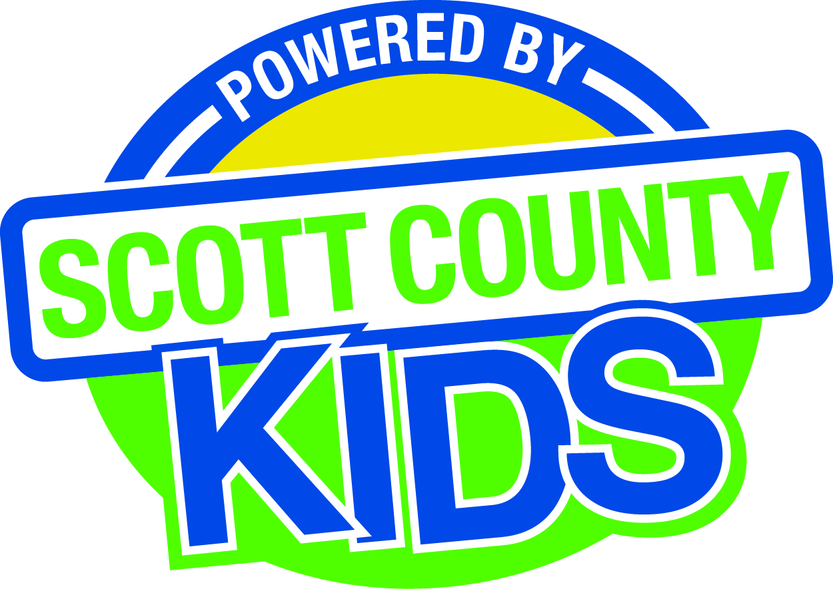
Scott County Kids Early Childhood Iowa Board
Meeting of September 1, 2015
Scott County Administrative Center
600 W. 4th Street, Davenport
1st floor Board Room
11:30am – 1:00 pm
You are welcome to bring your brownbag lunch.

Agenda
- Call to Order –Larry Barker, Chair
- Introductions

- Approval of Minutes for August 4, 2015

- Old Business
- Fiscal Issues
- FY15 Expenditures
- Levels of Excellence
  - Board Professional Development Plan (Action item)
  - Director Professional Development Plan (Action item)
  - Community Plan Strategies (Review)
- Maternal, Infant and Early Childhood (MIECHV)

- New Business
  - Presentation: Mary Jo Huddleston, Child Care Resource and Referral
  - Annual Report (Action item)
  - Bylaws (Review)
  - Policies and Procedures (Review)
  - Early Childhood Coordinating Council
  - Committee Reports
- Contracts Management
- Committee Report
- Outcomes
- Committee Report
- Nominations
- Committee Report
- Public Awareness
- Committee Report
- Community Meetings
  - State Early Childhood Iowa
    - State ECI Board Meeting: next mtg 9/11/15
    - State ECI Coordinator Meeting: next mtg 9/16/15
    - Survey
  - Legislative Recap

- Other Business

- Public Input

- Next Meeting October 6, 2015

