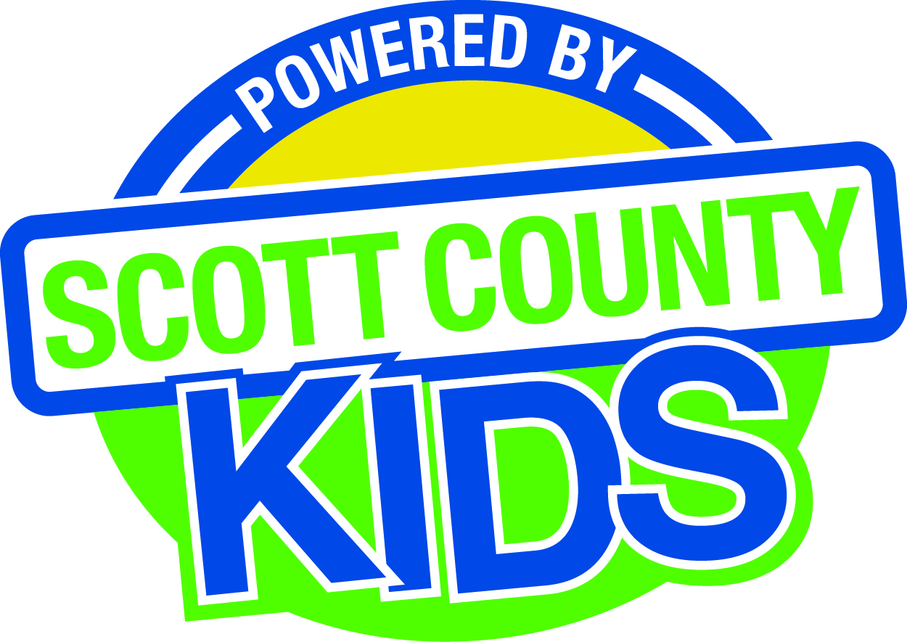
Scott County Kids Early Childhood Iowa Board
Meeting of September 2, 2014
Scott County Administrative Center
600 W. 4th Street, Davenport
1st floor Board Room
11:30am – 1:00 pm
You are welcome to bring your brownbag lunch.

Agenda

- Call to Order –Larry Barker, Chair
- Introductions

- Approval of Minutes for August 5, 2014

- Old Business
- Fiscal Issues
- FY14 Expenditures
- FY15 Expenditures
- FY15 Budget
- Maternal, Infant and Early Childhood (MIECHV)

- New Business
  - Annual Report
  - Bylaws (review)
  - Board Survey
  - Early Childhood Coordinating Council
  - Committee Reports
- Contracts Management
- Committee e Report
- Outcomes
- Committee Report
- Nominations
- Committee Report
- Public Awareness
- Committee Report
- Community Meetings
  - State Early Childhood Iowa
    - State ECI Board Meeting
    - State ECI Coordinator Meeting
    - Survey
  - Legislative Recap

- Other Business

- Public Input

- Next Meeting October 7, 2014

