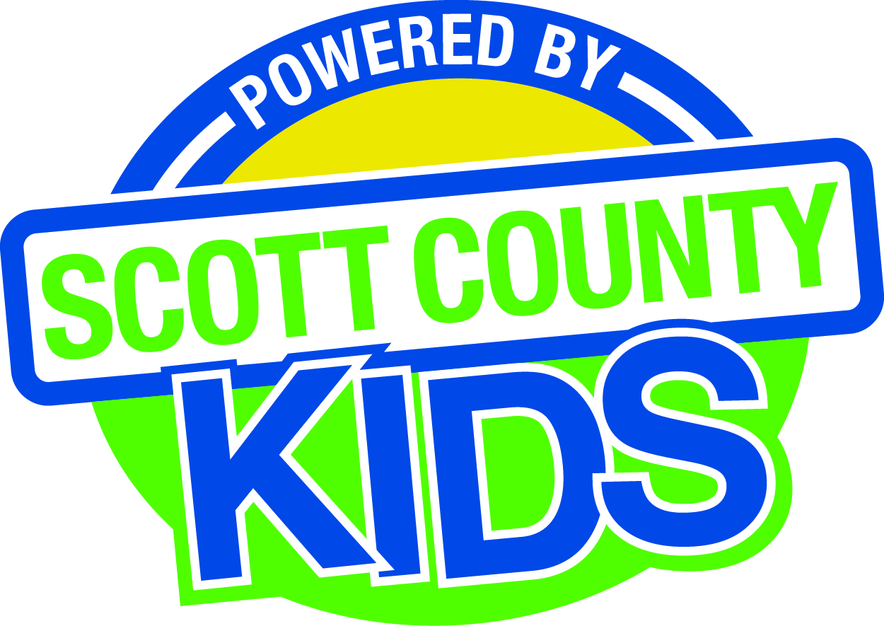
Scott County Kids Early Childhood Iowa Board
Meeting of October 7, 2014
Mississippi Bend AEA
729 21st Street, Bettendorf
Meeting Room B
11:30am – 1:00 pm
You are welcome to bring your brownbag lunch.

Agenda
- Call to Order –Lawrence Barker, Chair
- Introductions

- Approval of Minutes for September 2, 2014

- Old Business
- Fiscal Issues
- FY15 Expenditures
- Bylaws (action item)
- Maternal, Infant and Early Childhood (MIECHV)

- New Business
  - Early Childhood Coordinating Council
  - Committee Reports
- Contracts Management
- Committee Report
- Outcomes
- Committee Report
- Nominations
- Committee Report
- Public Awareness
- Committee Report
- Community Meetings
  - State Early Childhood Iowa
    - State ECI Board Meeting: scheduled11/7/14
    - State ECI Coordinator Meeting: 9/30/14 Listening Post
  - Legislative Updates

- Other Business

- Public Input

- Next Meeting November 4, 2014

