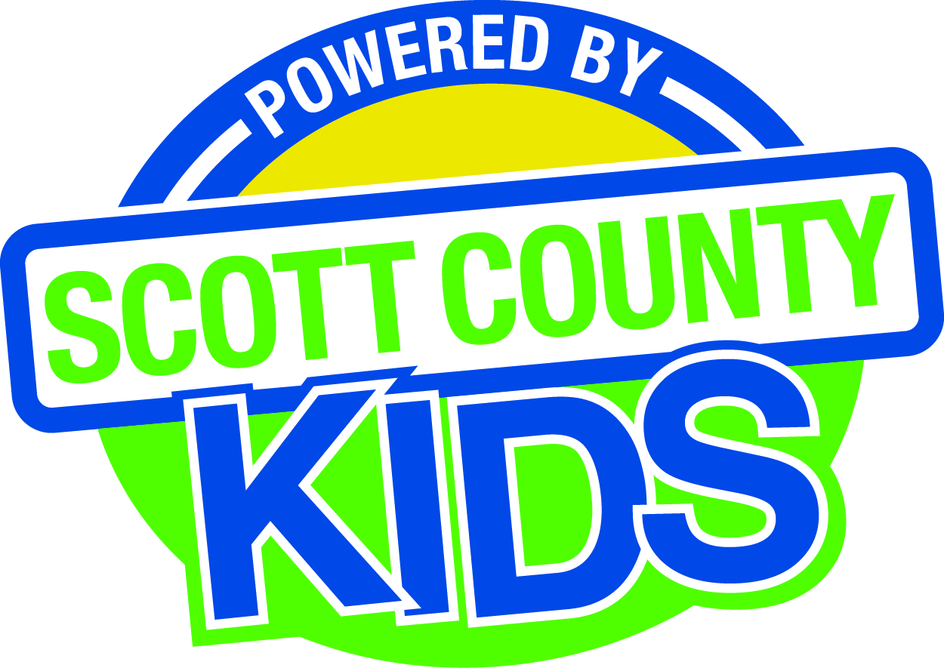
Scott County Kids Early Childhood Iowa Board
Meeting of June 3, 2014
Scott County Administrative Center
600 W. 4th Street, Davenport
Room 605
11:30am – 1:00 pm
You are welcome to bring your brownbag lunch.

Agenda
- Call to Order –Larry Barker , Chair
- Introductions

- Approval of Minutes for May 6, 2014

- Old Business
- Fiscal Issues
- FY14 Expenditures
- Levels of Excellence
- Maternal, Infant and Early Childhood (MIECHV)

- New Business
  - Review Community Wide Indicators and Trend Data
  - FY 15 Proposed Budget
  - FY15 Processes
    - Insurance
    - Fiscal Agent
  - Early Childhood Coordinating Council
  - Committee Reports
- Contracts Management
- Committee Report
- Friendly House
- Outcomes
- Committee Report
- Nominations
- Committee Report
- Public Awareness
- Committee Report
- Community Meetings
- Website
  - Fund Development
    - Grant updates
  - State ECI Board Meeting –Rich Clewell
  - Legislative Recap

- Other Business
  - Schedule of FY15 Meetings
  - Conflict of Interest Statement and Board Survey

- Public Input

- Next Meeting August 5, 2014

