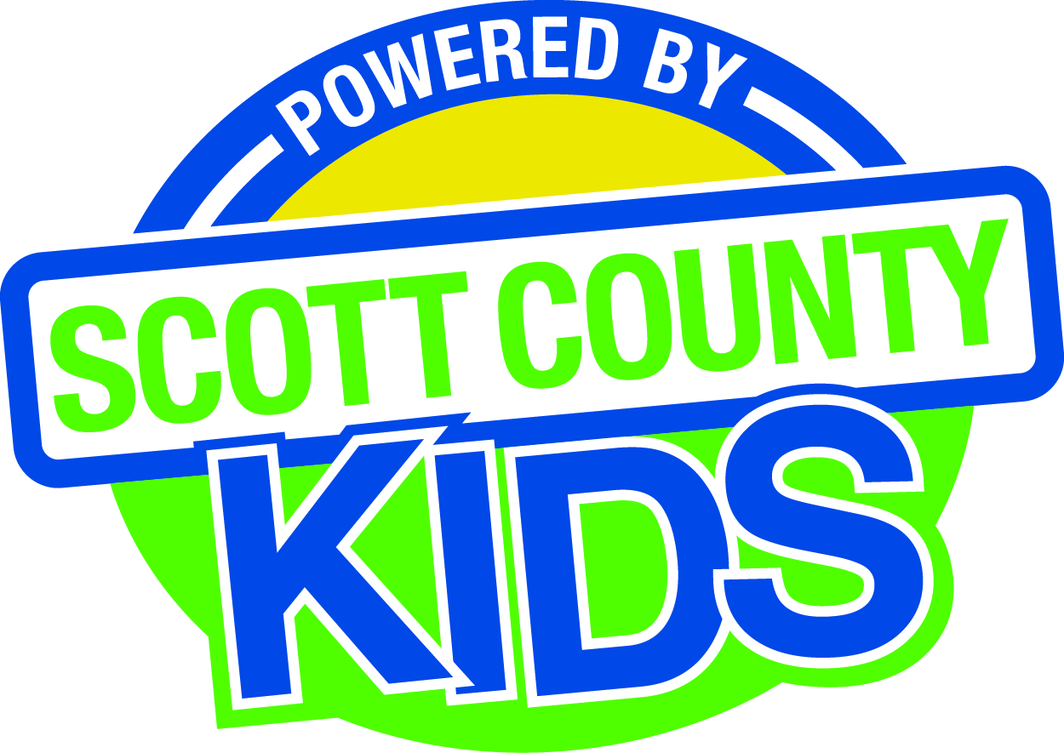
Scott County Kids Early Childhood Iowa Board
Meeting of August 5, 2014
Scott County Administrative Center
600 W. 4th Street, Davenport
First Floor Boardroom
11:30am – 1:00 pm
You are welcome to bring your brownbag lunch.

Agenda
- Call to Order –Larry Barker, Chair
- Introductions

- Approval of Minutes for June 3rd 2014 (Action Item)

- Old Business
- Fiscal Issues
- FY14 Expenditures
- FY15 Expenditures
- Levels of Excellence
- Maternal, Infant and Early Childhood (MIECHV)

- New Business
  - Early Childhood Coordinating Council –Kathy Bartling, AEA
  - Committee Reports
- Contracts Management
- Audit report FY13
- FY15 contracts –Tool G
- Bright Beginnings: credentialing and FTM (Action Item)
- AIM4Excellence –Newcomb staff (Action Item)
- Review of FY14 Federal funds
- Site Visit Summary
- Outcomes
- Nominations
- Re-election of board members
- Public Awareness
  - Evaluation and Salary Adjustment for Coordinator (Action Item)

  - Grant updates
    - RDA
  - State Early Childhood Iowa
    - State ECI Board Meeting: 6/6/14 Report from Clewell
    - State ECI Coordinator Meeting: 6/12 & 6/20 Report from Martens
  - Legislative Recap

- Other Business
  - Scott County Data Sheet
  - Reminder to submit Board Survey and Conflict of Interest forms

- Public Input

- Next Meeting September 2nd 2014

