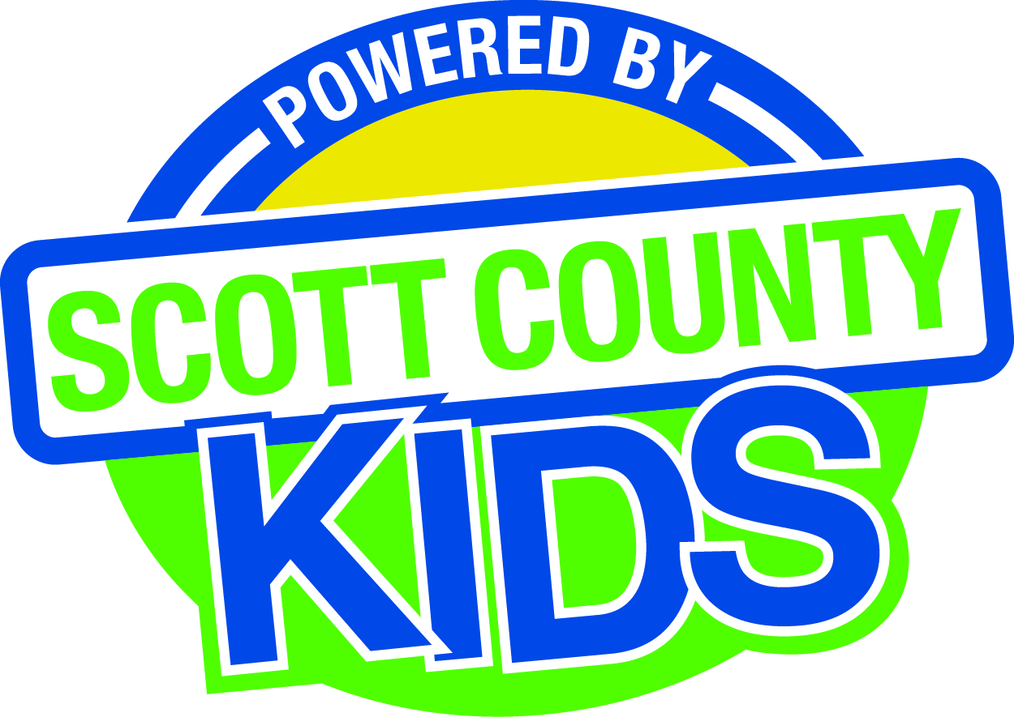
Scott County Kids Early Childhood Iowa Board
Meeting of December 2, 2014
Scott County Administrative Center
600 W. 4th Street, Davenport
Room 605
11:30am – 1:00 pm
You are welcome to bring your brownbag lunch.

Agenda
- Call to Order –Larry Barker, Chair
- Introductions

- Approval of Minutes for November 4, 2014
- Approval of revised Minutes for September 2, 2014

- Old Business
- Fiscal Issues
- FY15 Expenditures

- New Business
  - Presenter: Kendra Schaapveld; Lutheran Services in Iowa- MIECHV Parent Pals
  - Report out of meeting with Muscatine
  - Early Childhood Coordinating Council
  - Committee Reports
- Contracts Management
- Committee Report
- Outcomes
- Committee Report
- Nominations
- Committee Report
- Election of Officers
- Public Awareness
- Committee Report
- Community Meetings
  - Fund Development
    - Grant updates
  - State Early Childhood Iowa
    - State ECI Board Meeting: 11/7/14 Report from Martens
    - State ECI Coordinator Meeting: scheduled for 12/3/14
  - Legislative Recap

- Other Business

- Public Input

- Next Meeting January 6, 2015

